REGIONAL PLANNING PANEL
(Hunter Central Coast)

Supplementary Planning Report

JRPP No | PPSHCC-30
DA Number | DA/914/2019
Local Government Area | Central Coast Council
Proposed Development | Construction and use of the site for a Waste Transfer Station and ancillary works
Street Address | 5 Mooramba Avenue, Tuggerah, Lot 90 DP.4008
Date lodged | 25 September 2019
Applicant | All Town Skips c/- ADW Johnson
Architect: | Thomas Building Design
Number of Submissions: | No submissions
Estimated value: | CIV $943,223
Regional Development Criteria | Designated Development for waste management facilities or works, which meet the requirements for designated development under clause 32 of Schedule 3 to the Environmental Planning and Assessment Regulation 2000.
List of All Relevant s4.15(1)(a) Matters | - State Environmental Planning Policy No.55 – Remediation of Land  - State Environmental Planning Policy No. 33 - Hazardous and Offensive Development  - State Environmental Planning Policy 64 - Advertising and Signage  - State Environmental Planning Policy (State and Regional Development) 2011  - State Environmental Planning Policy (Infrastructure) 2007  - Wyong Local Environmental Plan 2013  - Wyong Shire Development Control Plan 2013  - Chapter 1.2 Notification of Development Proposals  - Chapter  - Chapter 2.11 - Parking and Access  - Chapter 3.1 Site Waste Management  - Chapter
List all documents submitted with this report for the panel’s consideration | Attachment 1 - Numerical Compliance Table  Attachment 2 - Draft recommended conditions  Attachment 3 - Plans
Recommendation | Conditional Approval
Report by | Salli Pendergast – Principal Development Planner- Development Assessment North

CENTRAL COAST COUNCIL

Development Assessment

Waste Transfer Station and ancillary works
DA/914/2019 Author: Salli Pendergast

SUMMARY

A development application has been received for a designated development for a Waste Transfer Station and ancillary works at 5 Mooramba Avenue Tuggerah. The application has been assessed having regard to the matters for consideration detailed in Section 4.15 of the Environmental Planning and Assessment Act 1979 and other statutory requirements.

Applicant All Town Skips c/- ADW Johnson
Owner Mr M M Harrison
Application No DA/914/2019
Description of Land 5 Mooramba Avenue, Tuggerah, Lot 90 DP.4008
Proposed Development Waste Transfer Station and ancillary works
Site Area 4047m²
Zoning IN2 Light Industrial
Existing Use Unauthorised waste transfer station operation
Employment Generation Up to 15 full time staff
Value of Works $943,223

RECOMMENDATION

- That the additional information provided by the applicant be considered in the Panel’s determination of the application.

- That the Regional Planning Panel grant consent to DA/914/2019 at 5 Mooramba Avenue, Tuggerah, for a Waste Transfer Station and ancillary works subject to the conditions provided in the Attachment.

- That Council advise those who made written submissions of its decision.

Background

The development application was considered by the Regional Planning Panel at its meeting held 14 October 2020.

The decision from the Panel was to defer determination of the application pending the resolution of several issues and preparation of this supplementary report. The Panel minutes stated:

The Panel agreed to defer the determination of the matter for the following information:

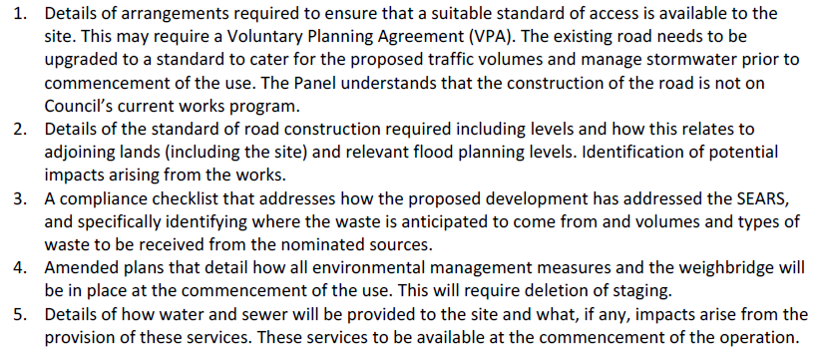
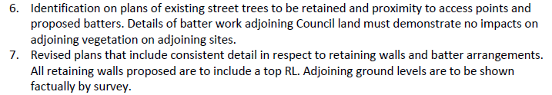
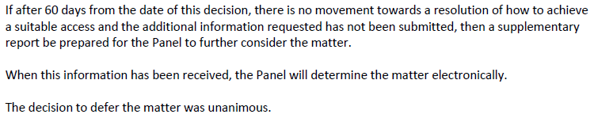

Matters raised by the Panel

The applicant has provided additional information and amended plans for further assessment in response to the above Panel deferral and a summary of the response is provided below.

Points 1 and 2 - Suitable Access and road construction details and impacts

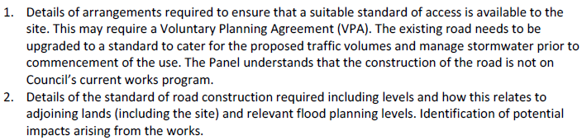

Applicant’s submission

The applicant’s position is that there is no justification to impose a condition of development consent requiring works to upgrade the entire length of Mooramba Avenue. In this regard, the applicant’s Traffic Engineer considers that the proposed development is not a high traffic generating development to justify specific road construction works. The proposed development does not result in the need for upgrade works to Mooramba Avenue. A condition requiring upgrade works will not serve a planning purpose and will not fairly and reasonably relate to the development.

In addition, the road construction works are already identified within Council’s applicable contributions plan. Legal advice has been provided by Sparke Helmore Lawyers to support this position and is provided as an attachment to the report. The applicant’s legal representative and traffic expert consider that it is not necessary to carry out the upgrade works for the proposed development.

Notwithstanding this, the applicant has advised that they are willing to undertake limited works by providing a two-coat seal to the existing pavement of Mooramba Avenue (as shown in the pavement plan included as an attachment to the report).

Contributions Plan

Council’s contributions plan (Wyong District Development Contributions Plan No.1) applies to the site. Under the plan, the site is included within a scheme identified as Zone 8: Tuggerah Industrial Estate Stage 3 – Roadworks. This scheme requires construction of road works including the construction of Mooramba Avenue.

Under Clause 3.4.11, the plan includes an applicable monetary contribution for construction of the road. Any favourable determination of the application will result in the imposition of a condition for the payment of a monetary contribution under Council’s Plan.

Ecological impacts

In relation to the road upgrade works, Council’s Ecologist has reviewed the amended plans and information for the proposal, including the proposed additional road works, and has raised no objection to such works provided the work proposed by the applicant or Panel, consist of resurfacing within the existing road width only.

In this regard, there should be no condition for any road works to be completed as part of the proposal that would impact the adjoining trees and vegetation along Mooramba Ave, as further assessment under the Biodiversity Conservation Act 2016 would be required.

Road Construction – Development

The Applicant has provided a Pavement Plan by ADW Johnson (refer Job No. 190110, Drawing No. ESK-006, dated 13/1/2021). An upgrade to a 2-coat bitumen seal for the entire length and existing pavement width of Mooramba Ave is proposed. These works are proposed in addition to the payment of any applicable contribution for roadworks for the development required under the Wyong District Contributions Plan.

Road Construction – Future

Mooramba Ave is identified in the Wyong District Contributions Plan as requiring an upgrade. The standard of road pavement is based upon 2 basic principles; that being the anticipated vehicle loadings and design life.

Recent experience during the roadworks undertaken for the Tuggerah Regional Sporting Complex identified that a significant pavement depth and stabilised material is required to provide an appropriate underlying pavement in Lake Road. This included the management of Acid Sulphate Soils. A similar requirement will be likely for the construction of Mooramba Avenue under the Contributions Plan.

The formation and width of the future road will generally be based upon an Industrial Local Street in Part 4 Subdivision contained in Council’s Development Control Plan 2013. This is detailed in Figure 1 below.

In accordance with Figure 1 below, Council will be required to upgrade Mooramba Avenue in the future to provide, as a minimum, kerb and channel, stormwater drainage, full road pavement, service allocations and driveway crossings to meet the existing and future uses in Mooramba Avenue. It is anticipated that the future road levels in Mooramba Avenue will likely be maintained to provide stormwater conveyance areas as well as lot freeboard as indicated in the Tuggerah Industrial Area Drainage Strategy. No design has been undertaken to date by Council for this area.

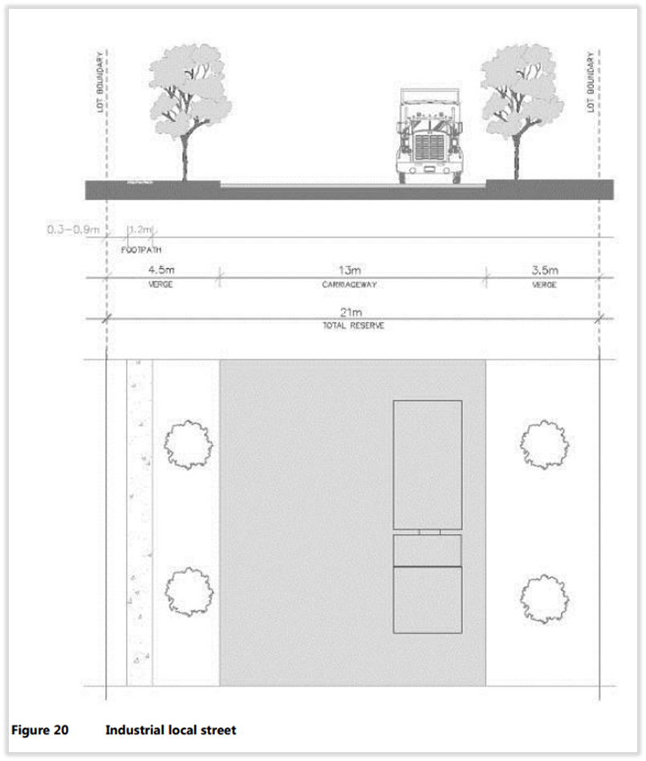

Figure 1 – Typical formation of an Industrial Local Street (DCP 2013 Figure 20)

Council will be required to undertake its own environmental assessment for the above roadworks under Part 5 of the Environmental Planning and Assessment Act 1979.

The Applicant has offered to provide additional works in the form of a 2-coat seal for the full extent of Mooramba Avenue. The width of the road under the proposed works would remain unchanged as existing. Such an upgrade would improve the manoeuvrability and supress dust from moving vehicles.

Council’s Senior Development Engineer has assessed the revised proposal noting that a full upgrade of Mooramba Avenue, including pavement, would be cost prohibitive (as is evidenced by Council’s recent experience with the reconstruction of Lake Road that services the Tuggerah Sporting Complex). In this regard, whilst supportive of the proposal, concern is raised regarding the proposed 2-coat seal in providing a durable and effective pavement solution in the longer term due to the potential wear caused by the heavy vehicles servicing the other adjoining properties along the street. As such, an alternative may be to stabilise the pavement.
Therefore, an amendment to condition 2.5 is recommended to require the construction of an upgraded pavement for the existing width and full length of Mooramba Avenue in either 2 coat seal or equivalent. This will allow for a satisfactory alternative treatment (at a similar cost) where more suitable.

The wording of condition 2.5 is therefore recommended to be amended to accommodate the proposed additional and alternative works (under subclause d) as follows:

2.5 Obtain a Roads Act Works Approval by submitting an application to Council for a Section 138 Roads Act Works Approval for all works required within the road reserve. The application is to be lodged using an Application for Subdivision Works Certificate or Construction Certificate, Roads Act Works Approval and other Development related Civil Works form.

The application is to be accompanied by detailed design drawings, reports and other documentation prepared by a suitably experienced qualified professional in accordance with Council’s Civil Works Specifications.

Fees, in accordance with Council’s Fees and Charges, will be invoiced to the applicant following lodgement of the application. Fees must be paid prior to Council commencing assessment of the application.

Design drawings, reports and documentation will be required to address the following works within the road reserve:

- Construction of two (2) industrial/commercial vehicle access crossings including construction of a heavy-duty gutter crossing and road pavement adjacent to the gutter crossing. A structural design to cater for anticipated loadings and detailing all concrete element must be provided. The design must consider the future upgrade of Mooramba Ave.

- Construction of any works required to transition new works into existing infrastructure and the surrounding land formation.

- Construction of a storm water drainage connection from the development site to Council’s storm water drainage system within the road reserve.

- Construction of an upgraded pavement (2 coat seal or equivalent at a similar cost to the applicant) for the existing width and full length of Mooramba Avenue.

The section 138 Roads Act Works Approval must be issued by Council and all conditions of that approval must be addressed prior to occupying and commencing any works in the road reserve.

In this instance, the provision of the proposed limited works as an interim measure is an appropriate outcome and is supported. Noting that in addition to these works, the proposal will also be subject to the payment of the required developer contribution for roadworks in accordance with the 7.11 Wyong District Contributions Plan as per recommended condition 2.4.

Point 3 - SEARS compliance checklist and Waste Details

A SEARS compliance table checklist has been provided by the applicant and is provided as an attachment to the report.

A Waste and Recycling Management Plan was also prepared for the proposal under Appendix Q of the EIS.

All Town Skips provide a waste collection services to the Central Coast and Hunter regions. Waste is anticipated to come from a variety of residential and commercial sources within these regions, with most of the waste collected by All Town Skips coming from residential uses. Given the nature and scale of the proposed All Town Skips operation, the target market is residential uses.

Operation of the Development is anticipated to generate the following broad waste streams:
- General waste and commingled recycling
- Food and organic wastes
- Bulk packaging wastes, including polystyrene and cardboard boxes
- E-wastes, and
- Bulky waste items, such as furniture.

Point 4 - Amended plans – environmental management measures & staging

Staging

The staging has been deleted from the application and the proposed development will be carried out in a single stage. Amended plans have been provided to reflect this arrangement. All environmental management measures required for the development of the
site will be undertaken in one stage.

Stormwater Runoff

Stormwater quality and quantity generated by the development will be managed on-site via a hydro-dynamic separation chamber and a stormwater detention and drainage system. The Applicant has proposed to construct on-site underground proprietary water quality and stormwater detention and drainage systems. These will treat stormwater from all new hard surface areas generating runoff to acceptable water quality and quantity targets, prior to discharge to the public drainage system (table drain) in Mooramba Avenue. No impact in Mooramba Ave will arise from the provision of stormwater runoff for the development.

In addition, a Positive Covenant and a Restriction on the Use of Land over these systems has been imposed as a recommended condition of consent (refer condition 5.7). This will ensure that they are properly maintained and provide public benefit post the issue of the Occupation Certificate.

Point 5 - Water and sewer servicing and impacts

Water supply – from Council’s 100mm PVC main in Mooramba Avenue

The subject site currently contains a water connection. The Applicant has provided a Water Account (Appendix I) detailing that the site has an existing water supply and meter arrangement.

Council’s property records indicate that the site is serviced via a 25mm 5 dial meter. The submitted Water Account assessment number 03194024 indicates that Council has accepted this existing arrangement with charges payable to the owner under the Water Management Act 2000. When compared to the existing land use, the development will not require any increased water supply. No impact will arise from the provision of water supply for the development.

Sewer supply – to Council’s 150mm PVC main traversing the front of the property

The existing sewer extends through the site along the front (eastern) boundary. The proposed connection to the sewer from the site office has been shown on the plans.

The Applicant has provided updated Civil Engineering Plans by ADW Johnson (refer Job No. 190110, Drawing No. REP-003, dated 13/1/2021). This details sewer from the proposed site office and amenities being directed to the existing sewer inspection opening located in the south-eastern corner of the site. This is detailed in Figure 2 below.

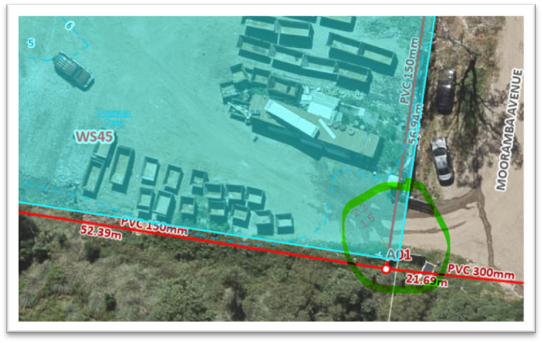

Figure 2 – Existing sewer inspection opening servicing the subject site

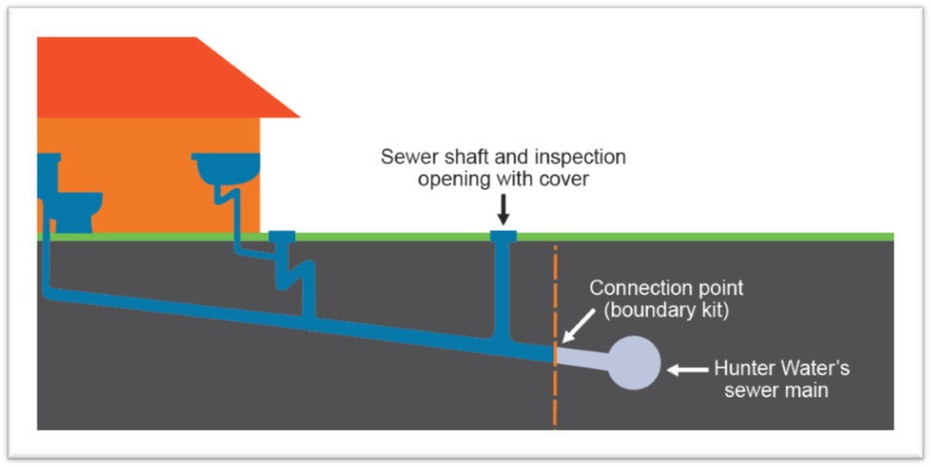

Figure 3 – Section of sewer through the property (image courtesy of Hunter Water website)

Figure 3 above details a typical section of a property sewer supply arrangement. The part circled in green above has already been constructed by Council. All sewer works are thus located internal to the site. No impact will arise from the provision of sewer supply for the development.

Council is also the Water Authority in this instance and under Section 307 of the Water Management Act 2000, will issue a Compliance Certificate when satisfactory water and sewer arrangements have been provided. A recommended condition to this effect (condition 5.8) has been included prior to the issue of an Occupation Certificate.

Point 6 - Street tree retention and impact to vegetation from proposed batters

The revised plans now identify the existing street tree to be retained, with proposed batters shown on the site regrade plan. The proposed batter works are highly unlikely to result in any impacts on the adjoining Council land to the south.

The proposed landscaped batters and landscaping will provide a visual buffer around the perimeter of the site. The proposed landscaping will result in well established mass planted batters which are aesthetically pleasing and low maintenance and are highly unlikely to impact on adjacent vegetation through the spreading of weeds.

A landscaped batter is proposed along the southern boundary and a partial retaining wall with a maximum height of 2m is proposed in the centre of the southern boundary. This retaining wall is positioned off the boundary, adjacent to the extent of the proposed hardstand area. A landscaped batter is provided between this retaining wall and the boundary. This will ensure a soft and appropriate transition to the land to the south for the full length of the southern boundary.

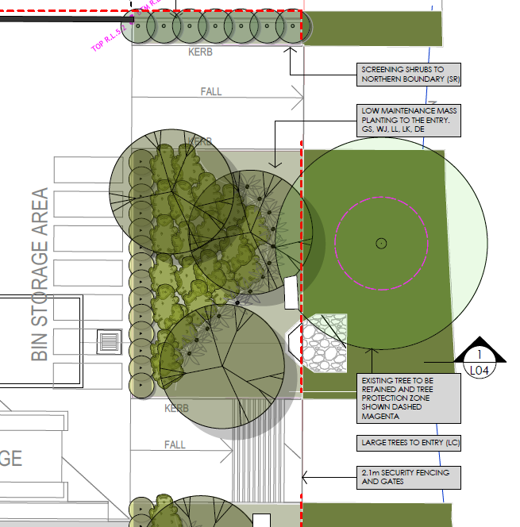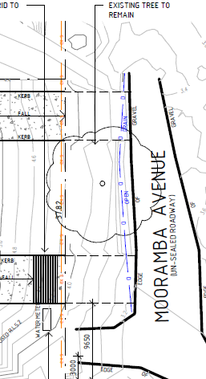

Above: Extract from landscape plan and site plan showing retention of street tree

The applicant has outlined the following mitigation measures relevant to the proposed landscaping and management of weeds proposed to be implemented:

- Best practice erosion and sedimentation control methods will be adopted, enforced and maintained throughout any earthworks during the construction phase to avoid having a negative impact on the surrounding bushland off-site;

- Weed control within the subject site will be undertaken to enhance the adjacent vegetation and prevent deterioration of threatened species’ habitat:

- Control of Senecio madagascariensis (Fireweed), Rubus anglocandicans (Blackberry), Ligustrum sinense (Small-leaf Privet), Acetosa sagittata (Turkey Rhubarb), Ageratina adenophora (Crofton Weed), Cinnamomum camphora (Camphor Laurel), Lonicera japonica (Japanese Honeysuckle), Ricinus communis (Castor Oil) and Solanum mauritianum (Wild Tobacco Bush) is required to be undertaken as these are listed under the Biosecurity Act 2015;

- Any other weeds will be controlled (as required);

- All weed control works will be undertaken by a suitably qualified contractor/individual with appropriate plant identification skills;

- Concentrations and dosage rates on targeted chemical control, will be determined with reference to the ‘Noxious and Environmental Weed Control Handbook’ (Ensbey, 2014). Any weed spraying will be conducted by an authorised person, having a Chemical Application Certificate or similar qualification. This will ensure that best practice is adhered to in consideration of the ecological sensitivities adjoining the study area.

The sections of retaining walls combined with soft engineering measures will provide a satisfactory outcome to protect adjacent vegetation, assist with weed control and ensure a suitable transition to surrounding lands in particular the site to the south.

Point 7 - Revised plans – consistency of details and levels shown

The plans have been amended to address the inconsistency between retaining wall and batter arrangement associated with the treatment of site boundaries. Elevations have been provided detailing the existing and proposed retaining walls when viewed from the northern and southern properties. Site levels have also been shown on the adjoining properties.

The updated plan sets include:

- Retaining wall details and batter arrangements;
- Top and bottom retaining wall RL; and
- Adjoining ground levels have been shown on the updated site regrade plan and updated concept engineering plans.

The applicant has also included elevations as part of the updated Landscape Plans which show the existing and proposed retaining walls when viewed from the northern and southern properties.

Changes to conditions

The conditions have been revised to refer to the latest amended plans and information and to remove reference to the staging. Additionally, condition 2.5 (as referred to above) has been revised to include reference to the additional road works proposed by the applicant and the removal of former point d in relation to the street tree.

Amendments have been made to the wording of Condition 3.9 to add reference to the tree in the road reserve to be retained and protected and to conditions 2.9 and 3.11 to add specific reference to the retention of the tree in the road reserve and all those bordering the site.

Further Information and Applicant’s response

The applicant has provided amended plans and a formal response to the Panel’s requested information which is provided as an attachment to this report.

Revised conditions have also been provided as an attachment to this report. The revised conditions address the matters previously raised by the Panel.

Conclusion

The application seeks approval for a Waste Transfer Station and ancillary works.

Additional plans and information have been provided by the applicant to satisfactorily address the matters raised in the meeting minutes of the Regional Planning Panel of 14 October 2020.

The information provided has been assessed by the Council relevant officers and the proposal is considered satisfactory with regard to the concerns previously raised. The site is in a suitable context for the nature, scale and type of the development proposed.

The proposal is recommended for approval subject to amended conditions.

ATTACHMENTS

Attachment 1 - Updated plans
Attachment 2 - SEARS compliance table checklist
Attachment 3 - Draft Conditions
Attachment 4 – Legal Advice (confidential) and Traffic Response

